Skin pack film for food
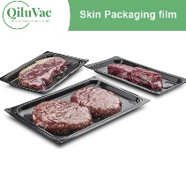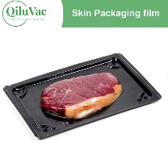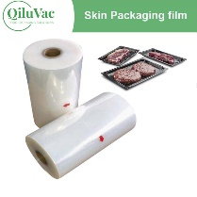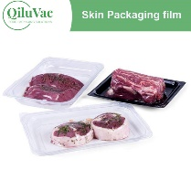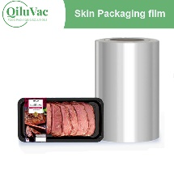
QiluVac skin pack film is a vacuum packaging film that looks like a second skin on the product and seals to the packaging without changing the product shape or decoration. Can be used for fresh, frozen, and processed food.

- Product Introduction
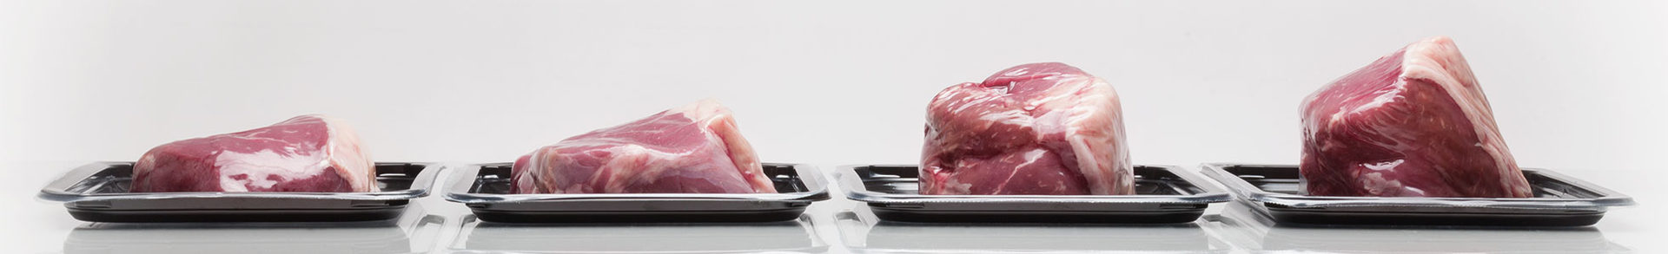
QiluVac Vacuum skin pack film is an easy to open film with strong, consistent peel properties for customer convenience.
Skin pack film for food greatly extends shelf life and reduces waste by preserving food, especially fresh meat products. Since the top skin film is sealed to the whole surface of the tray, which can prevent liquid from leaching out of the product.
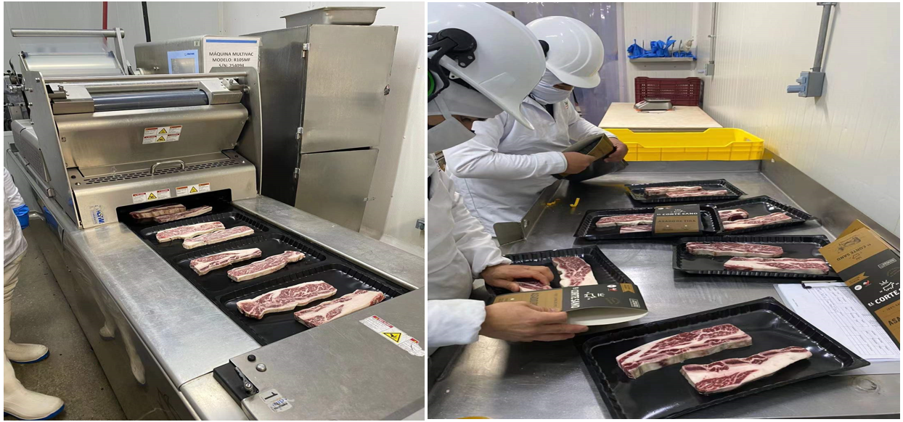
2. Application:
QiluVac skin pack film is suitable for harder and more stable products such as steak, sausage, cheese, or frozen food, and can be used for soft food like fish, thin fillets, or other seafood.
3.The advantages of food skin pack film:
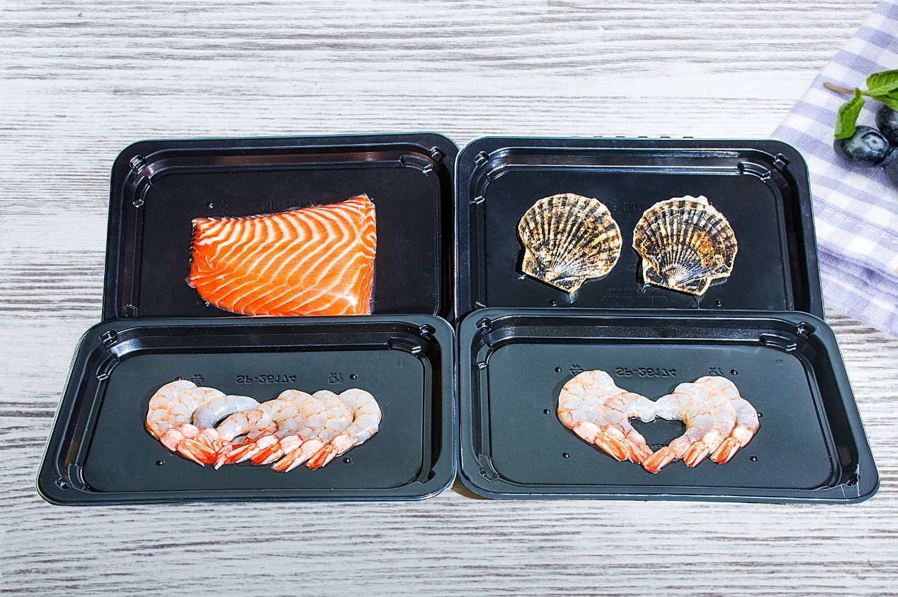
1). The novel packaging form and high appearance attract consumers and increases consumers' desire to buy.
The skin pack film is heated and packaged by the food vacuum packaging machine and packaged in a three-dimensional form. The skin pack film on the surface is closely attached to the product. Consumers can observe the product they want to buy more intuitively with have better vision, which can increase consumers' desire to buy.
2). The advantage of keeping fresh is obvious.
After the product is packaged by the skin pack film, the skin pack film is closely attached to the product, which can avoid the loss of product nutrients, and the advantage of keeping fresh is obvious.

4.Our Quality Control:
QiluVac has an advanced quality assurance program compliant of industry requirements and standards achieved by use of our detection flow system. The detection flow system adheres to the following quality control checks:
① Raw material testing
② Process control
③ Product testing
④ Quality checking
Laboratory Testing Instruments


5. Our Packaging details:
1)Roll with carton, then pallet; 2) Roll with bubble film, then pallet
